CALTON PRIMARY SCHOOL and CALTON PLAYGROUP
Safety, Health and Environment (SHE)

GCC COVID-19 RISK ASSESSMENT PROCESS FOR SCHOOLS (FROM STEP 4)

This is an update of the GCC COVID-19 Risk Assessment to support schools and educational settings from Step 4 of the Government Roadmap from 16th August 2021*. The aim of the risk assessment is to implement protective measures in the government’s operational guidance to protect your staff, pupils and community.

This update has moved away from the Assess – Plan – Do – Review model previously used (see below) into a more traditional risk assessment format that identifies each hazard, who is at risk, guidance on what you should be doing and any further actions that are required.
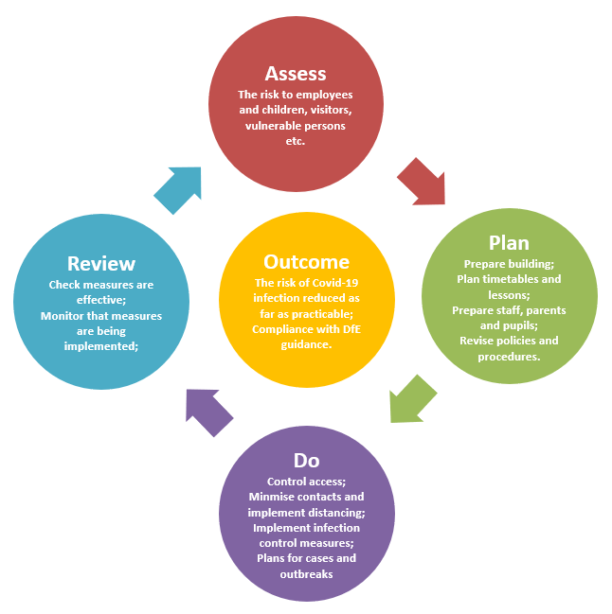
Each school/setting must consider their own situation and adapt the assessment by editing the measures where appropriate. Remove any measures that are not relevant or will not be applied in your setting and add any additional local measures that you are implementing, then complete the relevant columns.

Some people at work may have particular characteristics meaning they are at comparatively increased risk from COVID-19 (due to age, deprivation, ethnicity, pregnancy, etc.) and as employer the school must consider them in their risk assessment.

*Please note that this risk assessment may be updated before September 2021 in light of updates to government guidance.

This document has been updated on 12th November 2021 following an increase in changes in the local school community and changes to LA guidance.

COVID-19 Risk Assessment for Schools & Educational Settings

Risk Assessment for Calton Primary School
Hazards | Who is at risk? | What are you already doing? | Is enough to manage the risks? | What further action is necessary? | Action by whom? | Action by when? | Done
Person showing symptoms or positive test result | Employees  Pupils  Young People  Families  Contractors  Visitors  Members of the public | - Refer to GCC COVID Response Checklist and public health advice on testing, self-isolation and managing confirmed cases of COVID-19.  - Regular communications that persons are not to come into school if they have symptoms, have had a positive test result or other reasons requiring them to stay at home due to the risk of them passing on COVID-19 (e.g. they are required to quarantine).  - If anyone in your school develops COVID-19 symptoms they will be sent home.  - Staff caring for a child awaiting collection to keep a distance of 2 metres.  - Staff to wash their hands after caring for a child with symptoms.  - All areas where a person with symptoms has been to be cleaned after they have left.  - Follow threshold guidance in school outbreak management plan for reporting and managing an outbreak.  - School has sufficient supplies of PPE, face coverings, cleaning materials and hand washing/sanitising liquids.  - Update staff, pupils, stakeholders and visitors on changes in practice – covid safe measures.  - If a parent/carer insists on a pupil attending your school with symptoms, Headteacher may refuse the pupil if, in their reasonable judgement, it is necessary to protect other pupils and staff from possible infection with COVID-19. |  | Increase the use of home testing by staff (primaries)  Consider reintroducing face coverings and bubbles temporarily  Attendance restriction will only be recommended by the government as a last resort. | SLT | Year group bubbles have been reintroduced from 8th November 2021 apart from during lunchtimes when they are in phases: R/KS1/LKS2/UKS2  From 15th November 2021 staff will be advised to wear face coverings when moving around school outside of bubbles | Yes
Poor Personal Hygiene | Employees  Pupils  Young People  Families  Contractors  Visitors  Members of the public | - COVID-19 posters/ signage displayed.  - Frequent and thorough hand cleaning is regular practice.  - Pupils and staff to clean their hands when they arrive at school, when they return from breaks, when they change rooms and before and after eating.  - Sufficient handwashing facilities are available.  - Where there is no sink, hand sanitiser provided in classrooms.  - Staff help is available for pupils who have trouble cleaning their hands independently (e.g. small children and pupils with complex needs).  - Use resources such as “e-bug” to teach effective hand hygiene etc.  - Adults and pupils are encouraged not to touch their mouth, eyes and nose.  - Adults and pupils encouraged to use a tissue to cough or sneeze and use bins for tissue waste (‘catch it, bin it, kill it’).  - Tissues to be provided.  - Bins for tissues provided and are emptied throughout the day. |  | Put in place monitoring and supervision to make sure people are following any controls you have in place, including enhanced cleaning.
Spreading coronavirus from contact with surfaces, equipment and workstations | Employees  Pupils  Young People  Families  Contractors  Visitors  Members of the public | - Reduced clutter and removing difficult to clean items to make cleaning easier.  - Cleaning using standard cleaning products such as detergents and bleach, paying attention to all surfaces but especially ones that are touched frequently, such as door handles, light switches, work surfaces, remote controls and electronic devices.  - Surfaces that are frequently touched and by many people in common areas to be cleaned twice a day.  - Avoid sharing work equipment by allocating it on a personal basis or put cleaning regimes in place to clean between each user.  - Identify where you can reduce people touching surfaces, for example by leaving doors open (except fire doors), or providing contactless payment.  - Keep surfaces clear to make it easier to clean and reduce the likelihood of contaminating objects.  - Provide more bins and empty them more often.  - Toilets and communal areas to be cleaned regularly.  - Sanitising spray and paper towels to be provided in classrooms for use by members of staff.  - Thorough cleaning of rooms at the end of the day. |  | Put in place monitoring and supervision to make sure people are following controls, for example by implementing cleaning regimes.  Provide information telling people who should clean something and when.  Provide instruction and training to people who need to clean.  Include information on the products they need to use,  precautions they need to follow and the areas they need to clean
Poorly ventilated spaces leading to risks of coronavirus spreading | Employees  Pupils  Young People  Families  Contractors  Visitors  Members of the public | - Ventilation and AC systems working optimally.  - Carbon dioxide monitors used to quickly identify where ventilation needs to be improved.  - Heating used as necessary to ensure comfort levels are maintained when the building is occupied.  - Keep windows open wide enough to provide some natural background ventilation and open internal doors to increase air flow.  - Open windows fully when rooms are unoccupied for longer periods to purge the air (e.g. lunch times and before and after school).  - Action taken to prevent occupants being exposed to draughts. For example, partially open high-level windows as oppose to low-level windows, close external doors and arrange the furniture if appropriate and possible.  - Use fans for good air circulation.  - Occupants encouraged to wear additional, suitable indoor clothing. (If they have to wear coats, scarves and other outdoor clothing the room would be considered too cold and the above steps must be considered).  - Ensure staff meetings and insets are in rooms with suitable and sufficient ventilation. |  | Identify any poorly ventilated spaces take steps to improve fresh air flow in these areas.  Maintain air conditioning plant and equipment as per manufacturers instructions. | SBM | From 8th November, all non-essential visits will be cancelled and where able, meetings including staff meetings will take place online. | Yes
Increased risk of infection and complications for workers who are clinically extremely vulnerable and workers in higher- risk groups | Employees  Pupils  Young People  Families  Contractors  Visitors  Members of the public | - Identify who in the work force could be clinically extremely vulnerable and refer to government guidance and HSE and PHE guidance on protecting vulnerable workers during the pandemic on how to support workers in higher-risk groups and those who are clinically extremely vulnerable.  - Carry out a risk assessment of pregnant workers to identify the risk and measures to be taken.  - Some pregnant workers will be at greater risk of severe illness from coronavirus and they should stay at home as much as possible and work from home if they can.  - Where adjustments to the job or working from home is not possible pregnant workers will be suspended from work on paid leave. |  | Guidance on who is clinically extremely vulnerable and what further support may be available from Public Health England.  Keep under review completed individual risk assessments for pregnant workers. |  | Ongoing monitoring
Airborne spread of COVID | Employees  Pupils  Young People  Families  Contractors  Visitors  Members of the public | - Although from Step 4, face coverings will no longer be advised for pupils, staff and visitors, persons choosing to wear face coverings as a precaution will not be deterred when outside the classroom.  - Where staff are in enclosed and crowded spaces, face masks are recommended (but not required). |  |  |  | From 15th November 2021 staff will be advised to wear face coverings when moving around school outside of bubbles
Returning to work after summer closure | Employees  Pupils  Young People  Families  Contractors  Visitors  Members of the public | - Buildings and health and safety compliance checks continue to be undertaken (e.g. fire alarm, emergency lighting, water hygiene, lifts, etc.).  - Decide the tasks that need to be carried out as a priority. This will allow you to plan the order in which workers will return to your workplace and in what number.  - Information and instruction for returning workers to ensure clarity on arrangements for cleaning and hygiene and ventilation.  - Vaccination is a control measure against COVID so staff can be asked to confirm that they are vaccinated. This information will assist in the risk assessment for outbreak management plans.  - Communicate updates with supply staff and other temporary or peripatetic staff and volunteers to follow the school’s arrangements for managing and minimising risk.  - Staff to undertake twice weekly home tests whenever they are on site until at least the end of September.  - Review/update policies to reflect changes brought about by updated COVID-19 requirements.  - Ensure website is compliant with regards to the publishing of policies and risk assessment. |  | Encourage vaccination take up amongst eligible staff |  | Compliance checks are up to date and continually monitored as being complete on a monthly basis.  Data is collected about staff vaccinations.

Completed by: | Samantha Tovey | Date | 01/09/2021

Reviewed by | Date | Next Review Due
Samantha Tovey | 12/11/2021 | TBC

