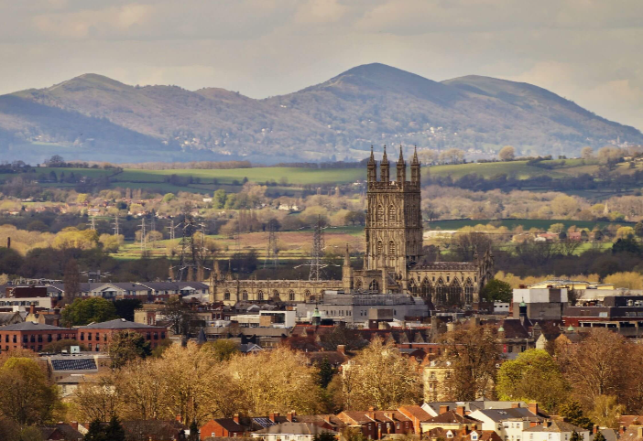

**Maths**

In Maths we will develop our understanding of place value, use column addition and subtraction and then move onto multiplication and division. We will also develop our knowledge of our number bonds and times tables in our Inter Rail practise.

**ART and D&T**

We will create our own trucks using a gear system. We will decorate them using truck art. We will develop our sketching techniques and research different artists. We will also sketch the Matchstick Factory. We will make naan bread and grow coriander to use when we hold our curry event.

**Music**

We will listen to, appraise and play a piece of music, which is a song about kindness, respect, friendship, acceptance and happiness.

**Science**

During practical lessons we will investigate what plants need to survive and how this can vary between different plants. We will also investigate the life cycle of a flowering plant. We learn about nutrients and how they are important to both humans and animals.

**Key vocabulary for this topic**

Gloucester Matchstick Cathedral Attractions

River Biomes Temperature Sketching

Biomes Mosque Robert Raikes Small Pox

Siege of Gloucester Cities Countries

Earthquake Flooding

**PE**

We will practise our Tag Rugby skills, linking with our theme. We will also be developing our skills in Gymnastics.

**R.E**

We will learn about the creation story before moving onto what matters to Muslims.

**English**

We will persuade someone to visit Gloucester. We will write a narrative story based on The Little Match Girl, we will perform poetry, write a non-chronological report about Gloucester and write to our MP.

**Geography & History**

Using atlases we will locate apital cities and countries in Europe and beyond. We will investigate the River Severn and how rivers are formed. We will investigate Biomes, temperature and forests. We will also look at earthquakes and how happen. In History we will investigate the history of Gloucester, identifying key events – looking at famous local people and their contribution to our city.

**PSHE**

We will explore all about us and what is important to us. We will also celebrate how we are all different.

**Y3 Glorious Gloucester**