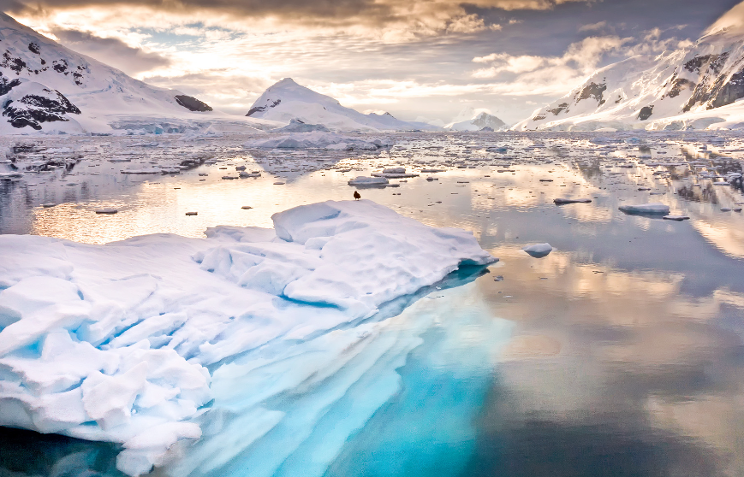
Maths
We will learn about column multiplication and division, explore money and immerse ourselves in statistics. We will then look at length and perimeter before finishing with fractions.
The Arctic
‘Pole to Pole’

Geography
We will be looking at the geographical features of the poles, understanding how the location affects these things and comparing the poles to Gloucester. We will plot the route taken by the explorers.
English
We will be learning about the Arctic through Non-Chronological reports, before studying the Lion, witch and wardrobe. We will write an explorer diary and write some poetry.
Art and D&T
We will be looking at the use of colour, tone and texture in pictures. We will analyse other artist’s work before painting a wintery scene using the skills we have learned.
In DT we will look at explorer clothing and design an item to take on an exploration.
Spanish
We will continue to develop our vocabulary and learn the days of the week and months of the year.
History
We will learn about different early explorers to the poles. We will investigate what life was like for them before becoming modern day explorers and follow in the footsteps of Scott Amundsen and Shackleton.

Science
We will learn about the human and animal skeleton and how much nutrition is needed for humans and animals.
PE
In net and wall we will look at our throwing and catching actions before applying these skills in game situations.
Music
We will be learning to follow and compose a piece of music using a range of instruments.
PSHE
We will be exploring ‘Dreams and Goals’ before moving on to ‘Healthy Me’
Key vocabulary
Arctic, Poles, ocean, animals, explorers, Arctic Fox, Walrus, Narwhal whale, Penguins, Polar Bear, Inuit, nutrition, protection, movement, skeleton, temperature, survival.
RE
We will be learning about festivals and worship for Muslims and also Jewish faiths.

